Terwerkstelling luchthaven

wp218En.pdf p16.
https://www.nbb.be/doc/ts/publications/wp/wp218En.pdf

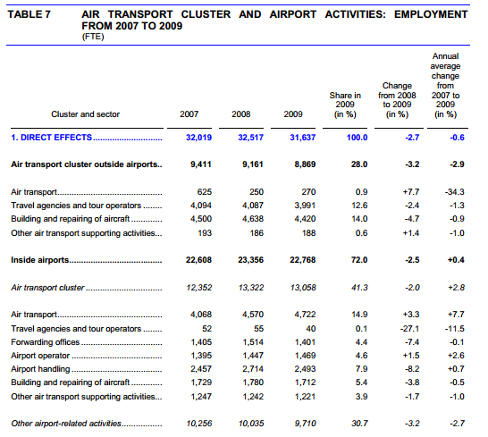

wp273En p18.
https://www.nbb.be/doc/ts/publications/wp/wp273En.pdf

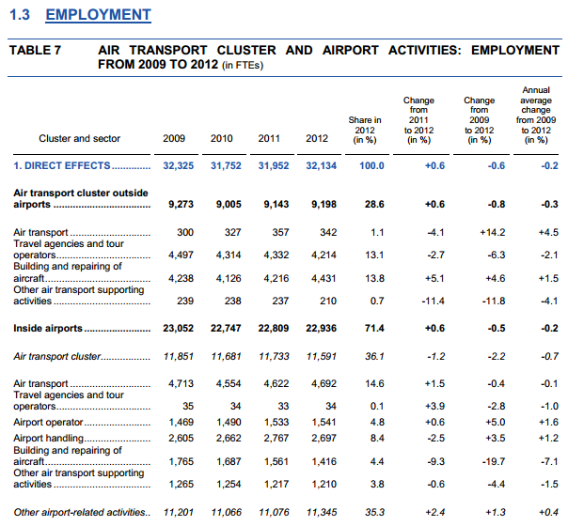

wp324en.pdf p15
https://www.nbb.be/doc/ts/publications/wp/wp324en.pdf

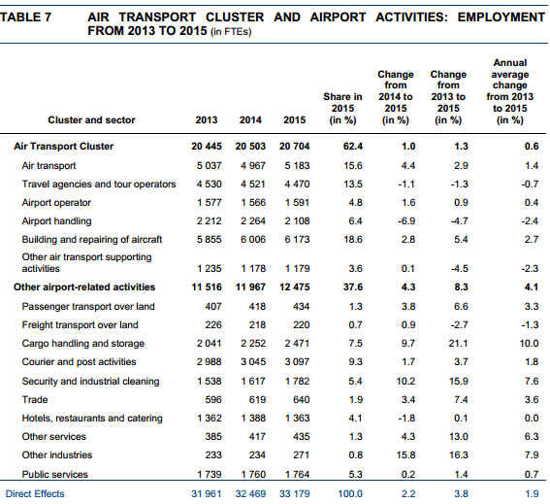
Bru Trends 2017.pdf p2 en p12
https://www.brusselsairport.be/en/our-airport/facts-figures/brutrends

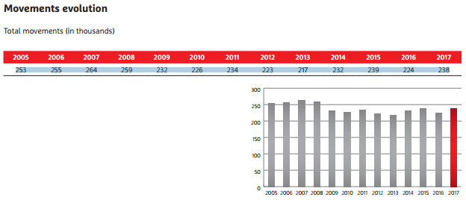
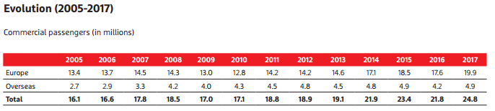

brutrends2017.pdf p24

